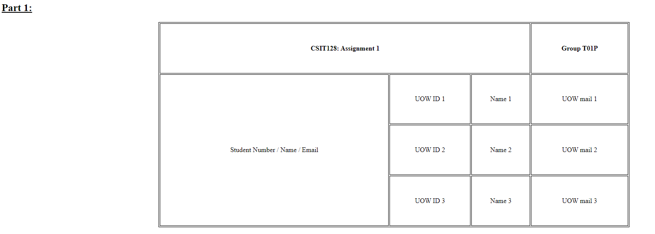
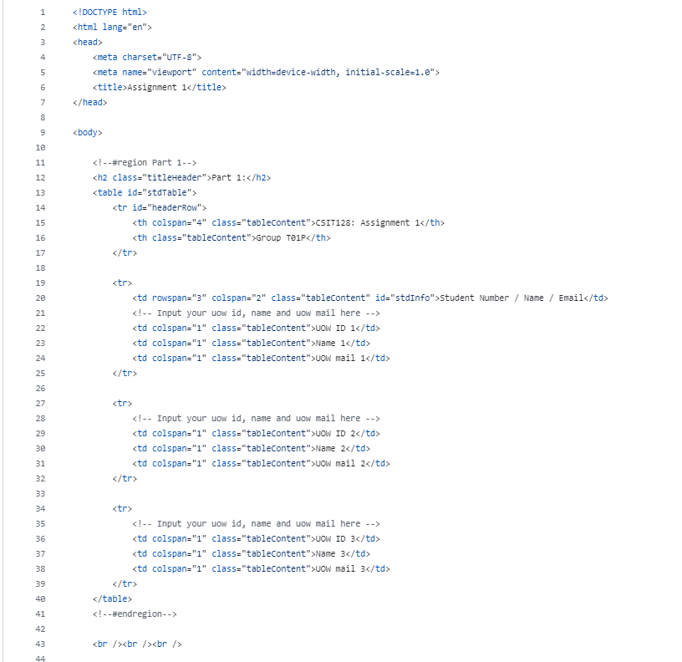
- 1.<!DOCTYPE html> This declaration specifies that the document follows HTML5 standard. It’s to ensure proper rendering in modern browsers.
- <html lang="en"> start the html document and set the language to English.
- <head> contains meta-information about the document.
- <meta> tags set the character encoding to UTF-8 and ensures the page is responsive on all devices by setting the viewport.
- <title> sets the title of the webpage.
- <body> contains the visible content of the webpage.
- <h2 class="titleHeader">Part 1:</h2> adds a header with the text “Part 1”.
- <table id="stdTable"> and <tr id="headerRow"> begins a table with the ID stdTable and table row with ID headerRow.
- <th colspan="4" class="tableContent">CSIT128: Assignment 1</th>
<th class="tableContent">Group T01P</th
Creates a header cell spanning 4 columns with the text “CSIT128: Assignment 1” and another header cell “Group T01P”.
- The next three rows display placeholder information for three students.
- <td rowspan="3" colspan="2" class="tableContent" id="stdInfo">Student Number / Name / Email</td>
The first column spans 3 rows and 2 columns, containing the text “Student Number / Name / Email”.
- <td colspan="1" class="tableContent">UOW ID 1</td>
<td colspan="1" class="tableContent">Name 1</td>
<td colspan="1" class="tableContent">UOW mail 1</td>
Each of the next three rows includes three cells spanning 1 column with respective text of UOW id, name and UOW email addresses of the three students.

- <br /><br /><br /> adds three lines break for spacing.

